Companie A- Able Plastics
Company B – Relative Plastics
- Do both companies have different GST numbers? yes
- Do invoices go out under both company names or only one company name? one company
- Can the same customer receive invoices from both companies? yes
Customers
- Are all customers shared between both companies? yes
- Has there ever been a customer that buys only from one company? no
Billing
- Eg of invoice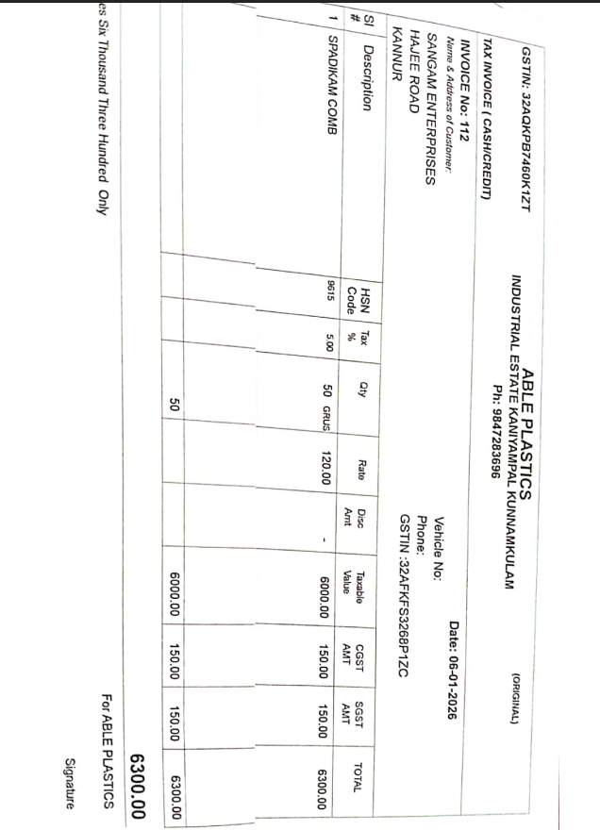

- Are invoice formats different? No , just name diff
Payments
- When a customer pays, do they pay:
- Company A separately? Yes , each one has diff bank acc
- Company B separately? Yes , each had diff bank account

